C++ ASSIGNMENT 4 (ARRAYS)

1. Write a program that asks the user to take array of 10 integers. The program must compute and

write how many integers are greater than or equal to 10.

#include <iostream>

using namespace std;

int main()

{

int a[10];

cout<<"Enter 10 numbers:"<<endl;

for(int i=0;i<10;i++)

{

cin>>a[i];

}

int n=0;

for (int i=0;i<10;i++)

{

if (a[i]>=10)

{

n++; // counting number greater or equal to 10 //

}

}

cout<<" "<<endl;

cout<<"no. of integers greater than or equal to 10 is: "<<n;

return 0;

}

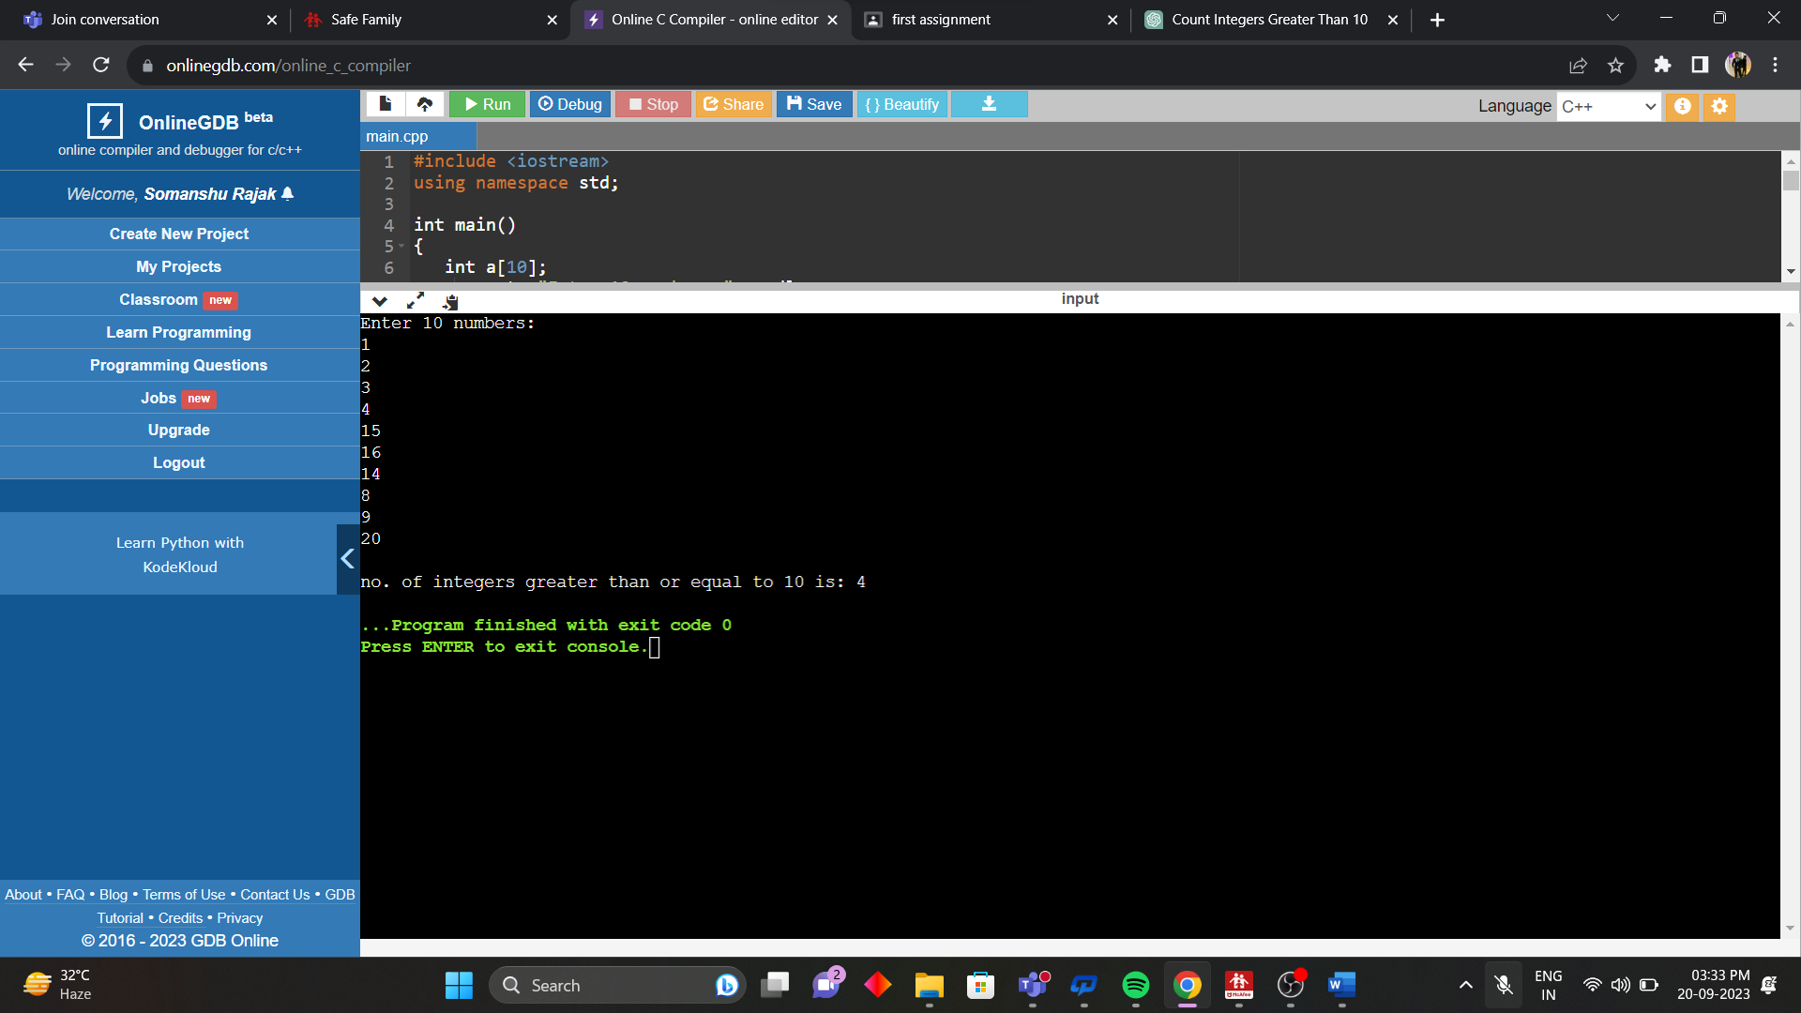

2. Write a program that asks the user to take array of 10 integers. The program must output the largest

element in the array, and the index at which that element was found.

#include <iostream>

using namespace std;

int main()

{

int a[10],n=a[0],indexOfLargest;

cout<<"Enter 10 numbers:"<<endl;

for(int i=0;i<10;i++)

{

cin>>a[i];

}

for (int i=1;i<10;i++)

{

if (a[i]>n)

{

n=a[i]; // largest //

indexOfLargest=i;

}

}

cout<<" "<<endl;

cout<<"largest number is : "<<n<<endl;

cout<<"index of largest number :"<<indexOfLargest;

return 0;

}

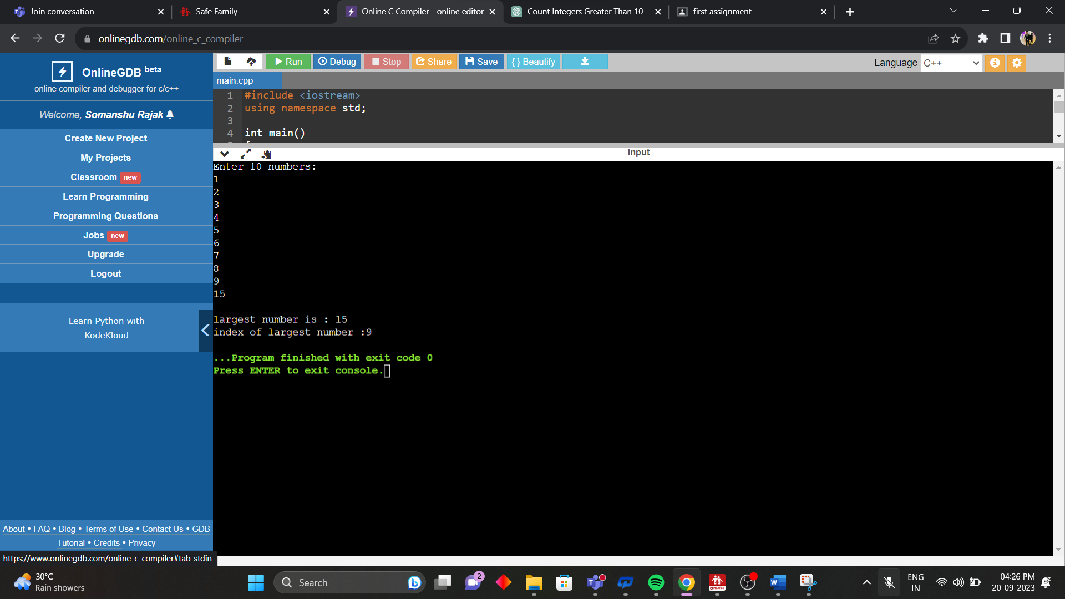

3. Write a program that asks the user to take array of 10 integers. The program will then sort the array in descending order and display it.

#include <iostream>

#include <algorithm>

using namespace std;

bool compare(int a, int b)

{

return a > b;

}

int main()

{

int arr[10];

cout << "Enter 10 numbers: " <<endl;

for (int i = 0; i < 10; i++) {

cin >> arr[i];

}

sort(arr, arr + 10, compare);

cout << "The sorted array in descending order is: " << endl;

for (int i = 0; i < 10; i++) {

cout << arr[i] << " ";

}

cout << endl;

return 0;

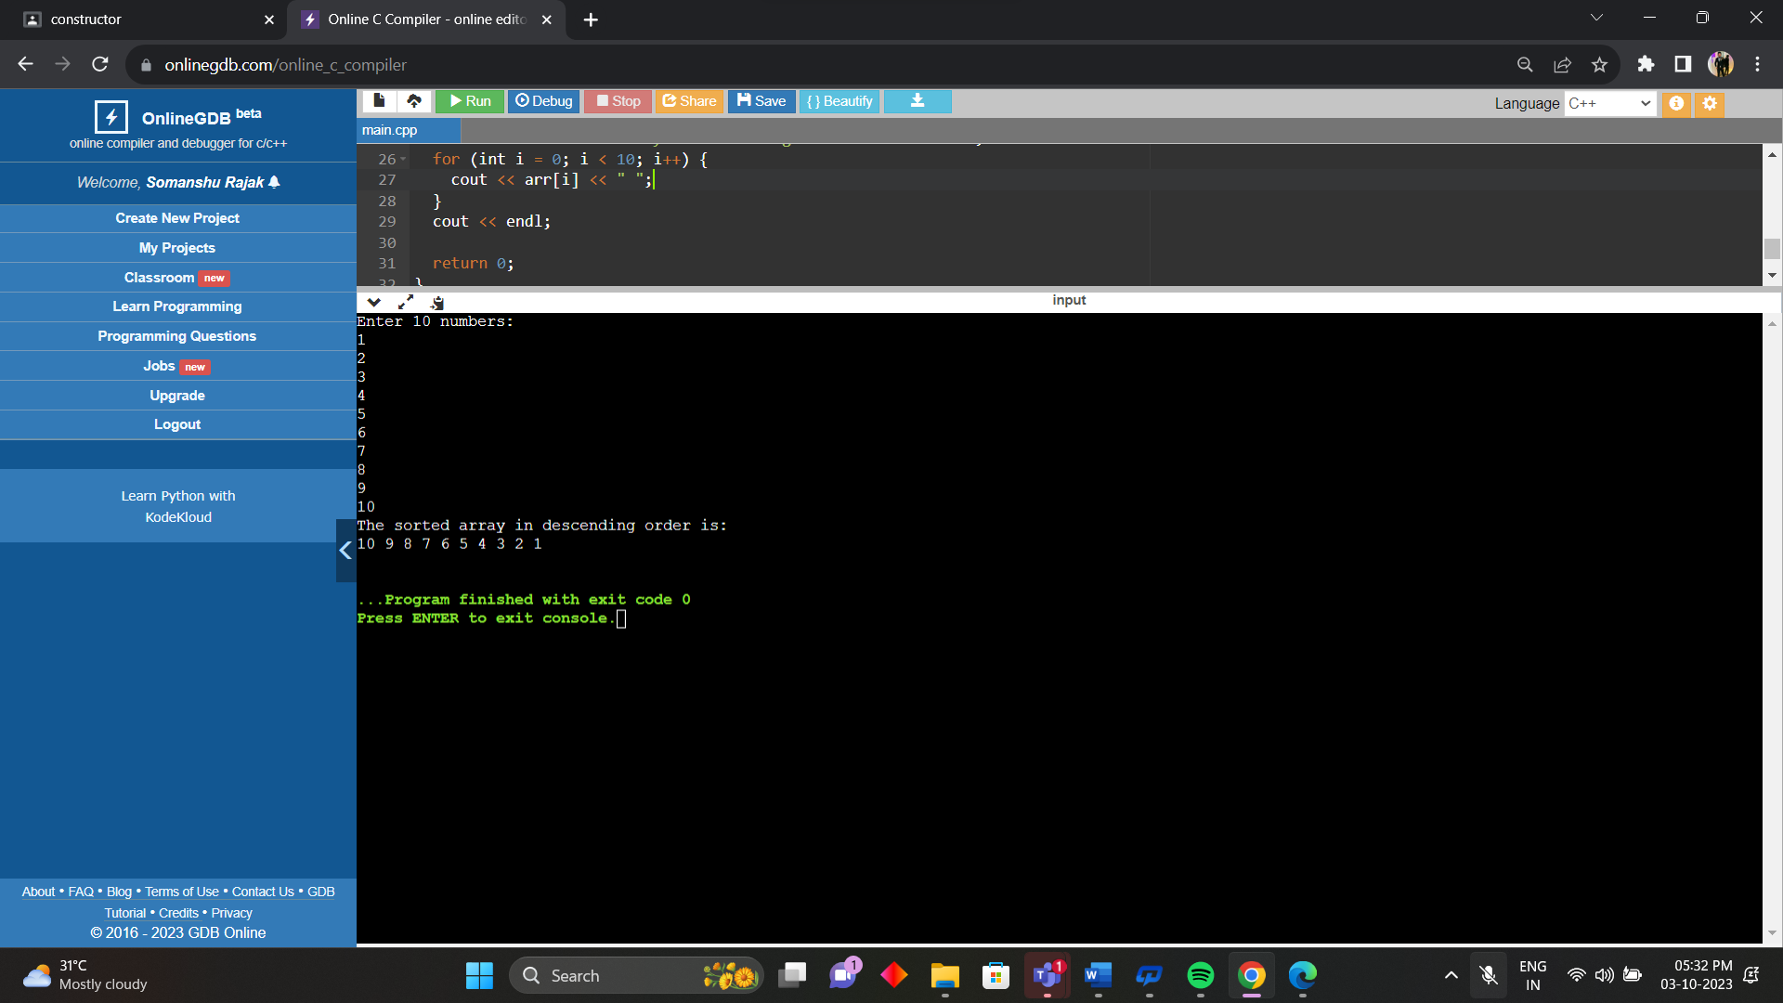

4. Write a program that asks the user to take array of 10 integers. The program will then display either &quot;the array is growing&quot;, &quot;the array is decreasing&quot;, &quot;the array is constant&quot;, or &quot;the array is growing and decreasing.&quot;

#include <iostream>

using namespace std;

int main()

{

int arr[10];

cout << "Enter 10 numbers: " << endl;

for (int i = 0; i < 10; i++)

{

cin >> arr[i];

}

string status = "";

for (int i = 0; i < 9; i++)

{

if (arr[i] < arr[i+1])

{

s

status += "g";

} else if (arr[i] > arr[i+1])

{

status += "d";

} else

{

status += "c";

}

}

if (status == "growing")

{

cout << "The array is growing." << endl;

}

else if (status == "decreased")

{

cout << "The array is decreasing." << endl;

} else if (status == "constant")

{

cout << "The array is constant." << endl;

} else

{

cout << "The array is neither growing nor decreasing." << endl;

}

return 0;

}

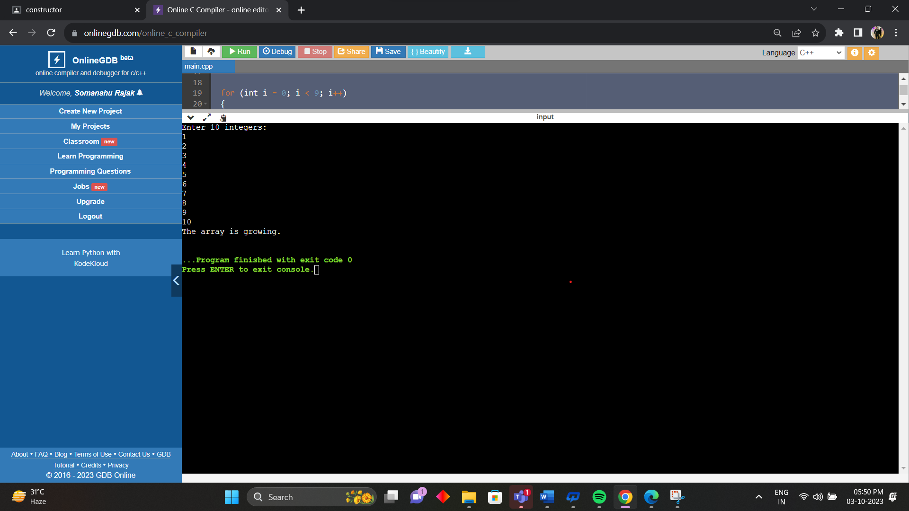

5. Write a program which takes 2 arrays of 10 integers each, a and b. c is an array with 20 integers.

The program should put into c the appending of b to a, the first 10 integers of c from array a, the

latter 10 from b. Then the program should display c.

#include <iostream>

using namespace std;

int main() {

int a[10];

int b[10];

int c[20];

cout << "Enter 10 integers for array a: " << endl;

for (int i = 0; i < 10; i++) {

cin >> a[i];

}

cout << "Enter 10 integers for array b: " << endl;

for (int i = 0; i < 10; i++) {

cin >> b[i];

}

for (int i = 0; i < 10; i++) {

c[i] = a[i];

}

for (int i = 10; i < 20; i++) {

c[i] = b[i-10];

}

cout << "The array c is: " << endl;

for (int i = 0; i < 20; i++) {

cout << c[i] << " ";

}

cout << endl;

return 0;

}

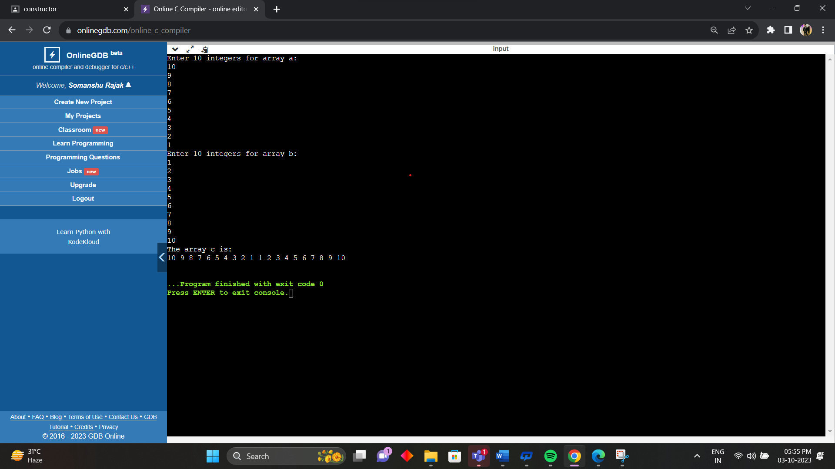

6. Write a program that asks the user to take an array of 10 integer and an integer value V and an

index value i between 0 and 9. The program must put the value V at the place i in the array,

shifting each element right and dropping off the last element. The program must then write the

final array.

#include <iostream>

using namespace std;

int main() {

int arr[10];

int V, i;

cout << "Enter 10 integers for the array: " << endl;

for (int j = 0; j < 10; j++) {

cin >> arr[j];

}

cout << "Enter an integer value V: " << endl;

cin >> V;

cout << "Enter an index value i between 0 and 9: " << endl;

cin >> i;

for (int j = 9; j > i; j--) {

arr[j] = arr[j-1];

}

arr[i] = V;

cout << "The final array is: " << endl;

for (int j = 0; j < 10; j++) {

cout << arr[j] << " ";

}

cout << endl;

return 0;

}

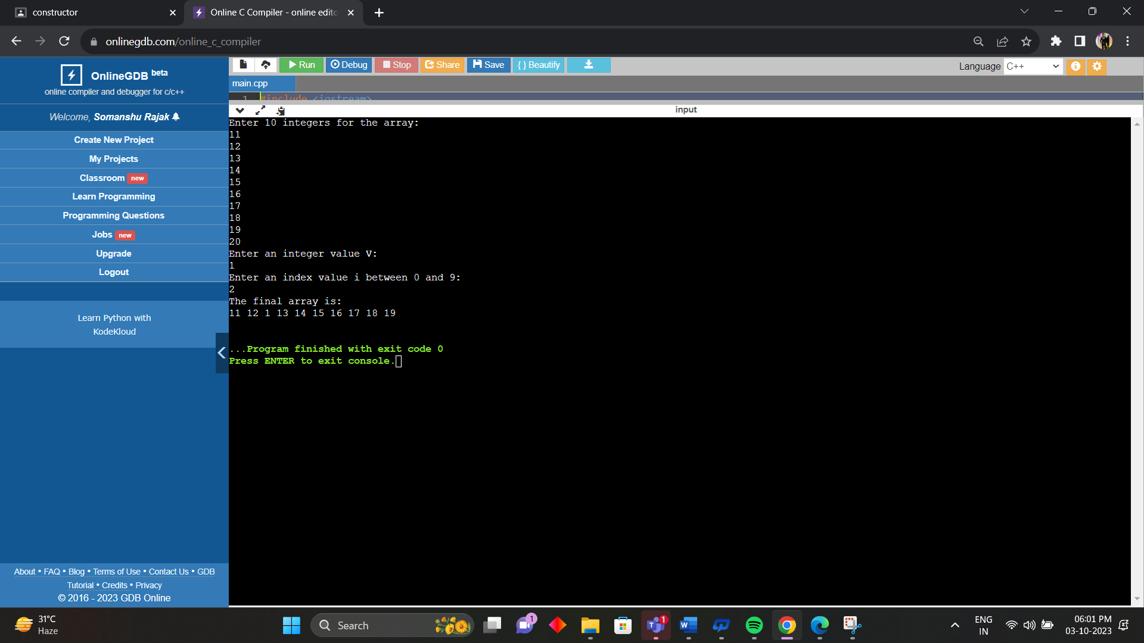

7. Write a program to handle the command line arguments entered by the user.

#include <iostream>

using namespace std;

int main(int argc, char\* argv[]) {

// display a message to the user

cout << "You have entered " << argc << " command line arguments." << endl;

// loop through the argv array and display each argument

for (int i = 0; i < argc; i++) {

cout << "Argument " << i << ": " << argv[i] << endl;

}

return 0;

}

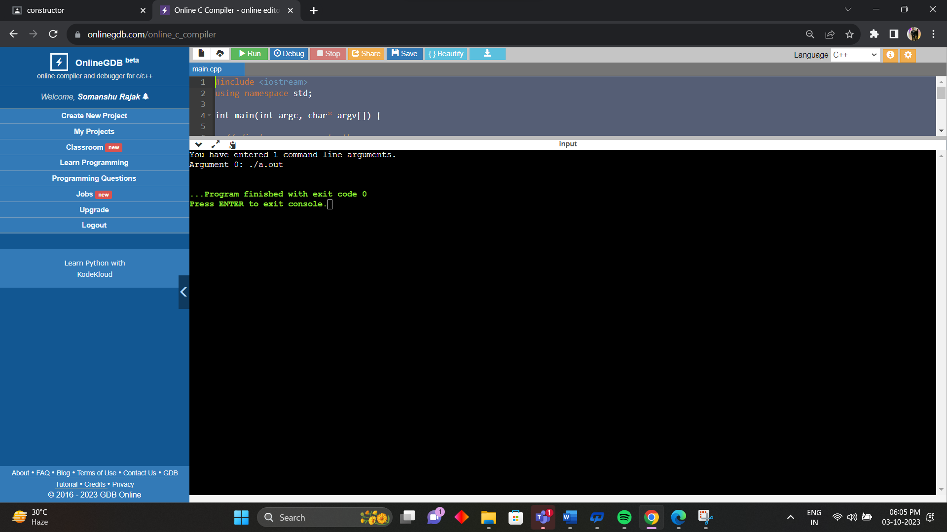

8. Write a program to add 2 matrices.

#include <iostream>

using namespace std;

int main() {

// declare two matrices of size 3x3, A and B

int A[3][3];

int B[3][3];

// declare a matrix of size 3x3, C, to store the sum of A and B

int C[3][3];

// ask the user to enter the elements of matrix A

cout << "Enter the elements of matrix A: " << endl;

// loop through the rows and columns of matrix A and store the user input

for (int i = 0; i < 3; i++) {

for (int j = 0; j < 3; j++) {

cin >> A[i][j];

}

}

// ask the user to enter the elements of matrix B

cout << "Enter the elements of matrix B: " << endl;

// loop through the rows and columns of matrix B and store the user input

for (int i = 0; i < 3; i++) {

for (int j = 0; j < 3; j++) {

cin >> B[i][j];

}

}

// add the corresponding elements of A and B and store the result in C

// loop through the rows and columns of C

for (int i = 0; i < 3; i++) {

for (int j = 0; j < 3; j++) {

// add the elements at position (i,j) of A and B and assign it to C[i][j]

C[i][j] = A[i][j] + B[i][j];

}

}

// display the matrix C

cout << "The sum of matrix A and B is: " << endl;

for (int i = 0; i < 3; i++) {

for (int j = 0; j < 3; j++) {

cout << C[i][j] << " ";

}

cout << endl;

}

return 0;

}

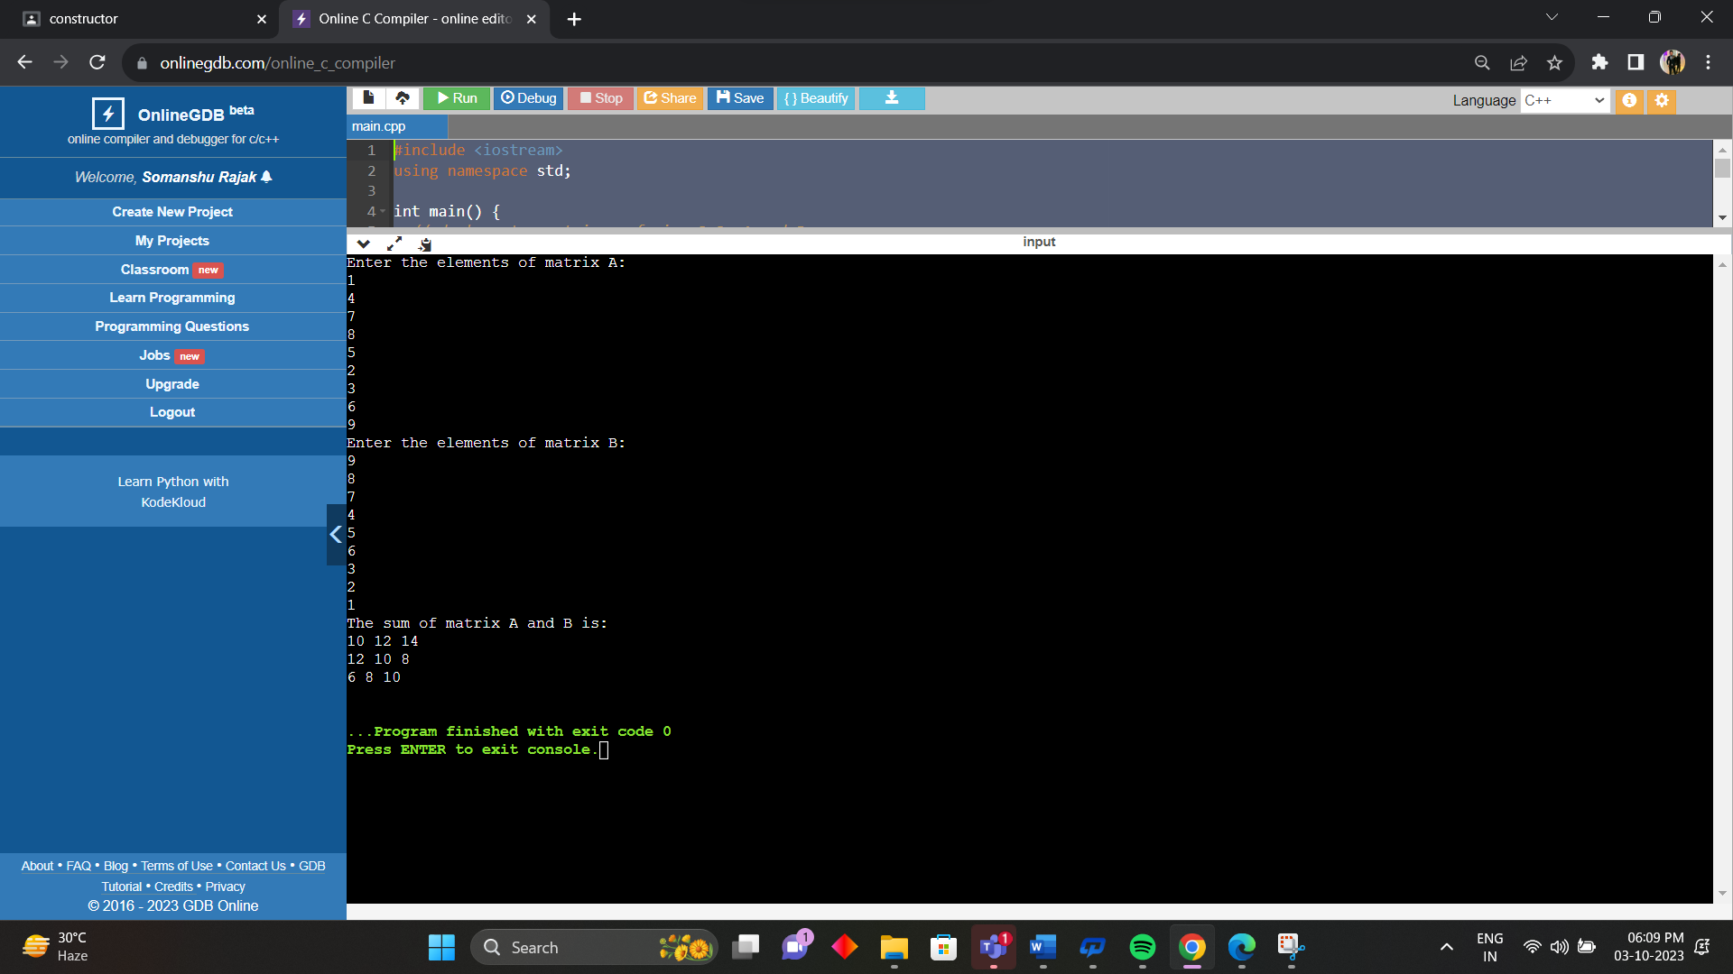

9. Write a program to multiply 2 matrices.

#include <iostream>

using namespace std;

int main() {

// declare two matrices of size 3x3, A and B

int A[3][3];

int B[3][3];

// declare a matrix of size 3x3, C, to store the product of A and B

int C[3][3];

// initialize the matrix C with zeros

for (int i = 0; i < 3; i++) {

for (int j = 0; j < 3; j++) {

C[i][j] = 0;

}

}

// ask the user to enter the elements of matrix A

cout << "Enter the elements of matrix A: " << endl;

// loop through the rows and columns of matrix A and store the user input

for (int i = 0; i < 3; i++) {

for (int j = 0; j < 3; j++) {

cin >> A[i][j];

}

}

// ask the user to enter the elements of matrix B

cout << "Enter the elements of matrix B: " << endl;

// loop through the rows and columns of matrix B and store the user input

for (int i = 0; i < 3; i++) {

for (int j = 0; j < 3; j++) {

cin >> B[i][j];

}

}

// multiply the corresponding rows of A and columns of B and store the result in C

// loop through the rows of A

for (int i = 0; i < 3; i++) {

// loop through the columns of B

for (int j = 0; j < 3; j++) {

// loop through the common dimension of A and B

for (int k = 0; k < 3; k++) {

// add the product of A[i][k] and B[k][j] to C[i][j]

C[i][j] += A[i][k] \* B[k][j];

}

}

}

// display the matrix C

cout << "The product of matrix A and B is: " << endl;

for (int i = 0; i < 3; i++) {

for (int j = 0; j < 3; j++) {

cout << C[i][j] << " ";

}

cout << endl;

}

return 0;

}

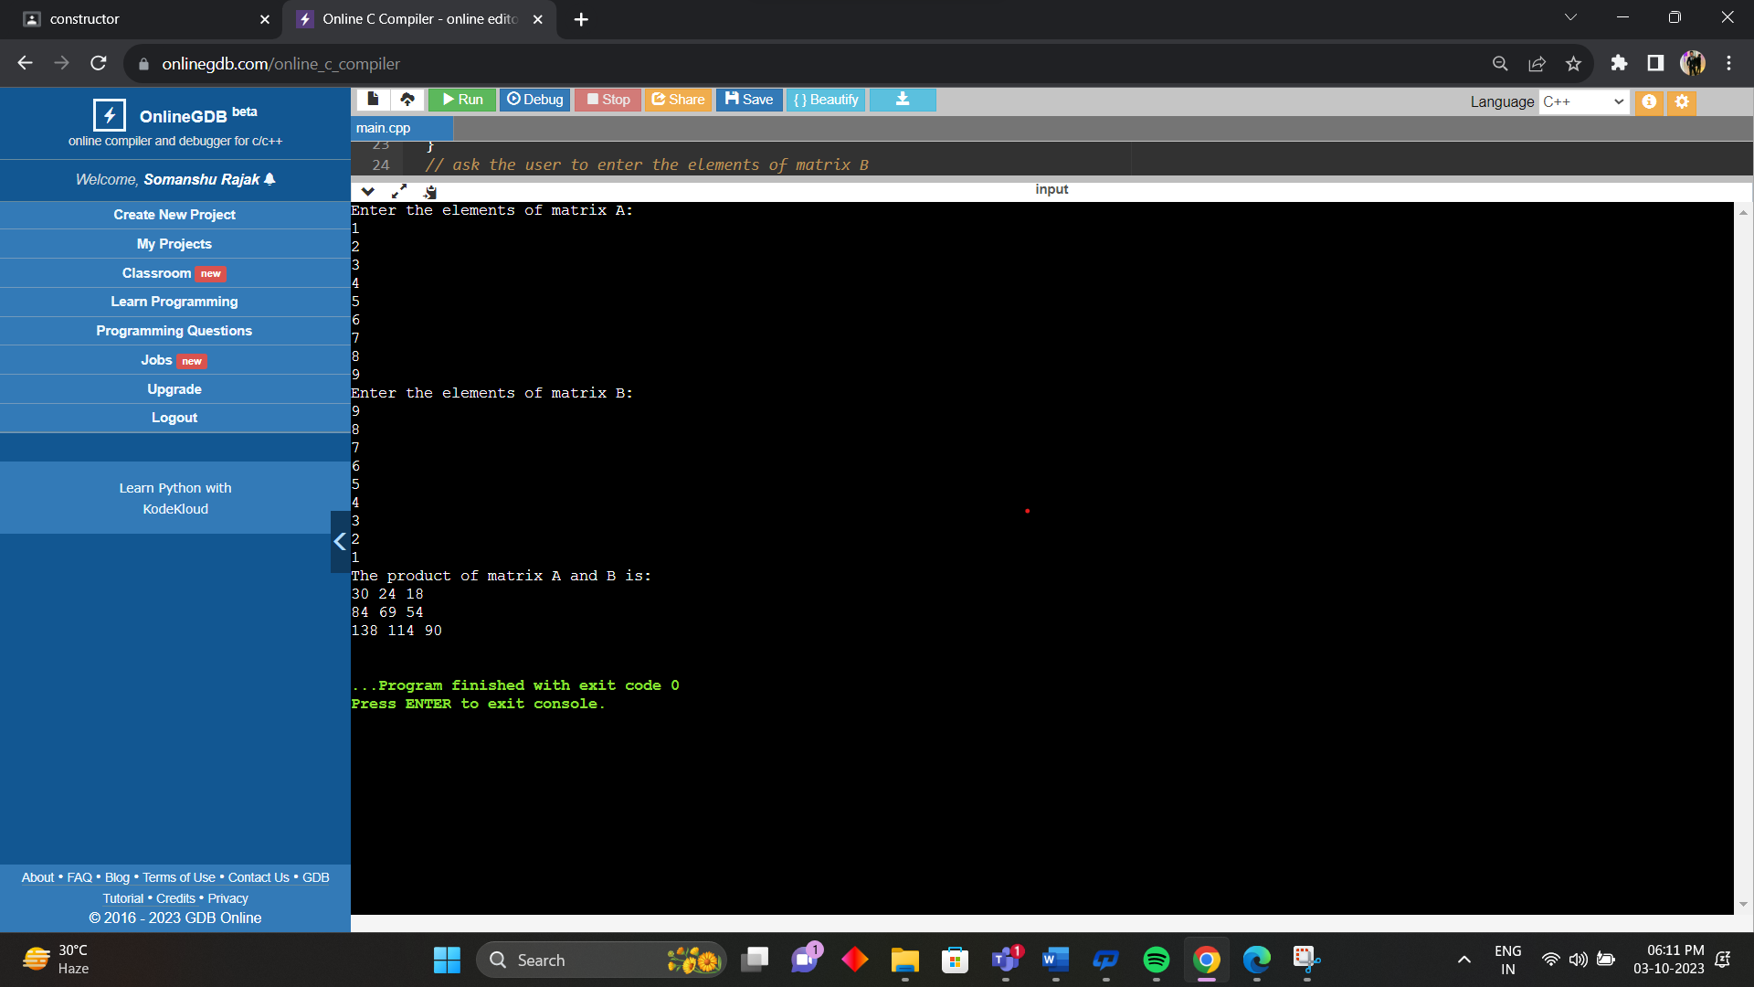

10. Write a program to implement sorting an array.

#include <iostream>

#include <algorithm>

using namespace std;

int main() {

// Declare an array of integers

int arr[] = {5, 2, 7, 9, 1, 4, 6, 8, 3};

// Get the size of the array

int n = sizeof(arr) / sizeof(arr[0]);

// Print the original array

cout << "Original array: ";

for (int i = 0; i < n; i++) {

cout << arr[i] << " ";

}

cout << "\n";

// Sort the array using the sort function from the algorithm library

sort(arr, arr + n);

// Print the sorted array

cout << "Sorted array: ";

for (int i = 0; i < n; i++) {

cout << arr[i] << " ";

}

cout << "\n";

return 0;

}

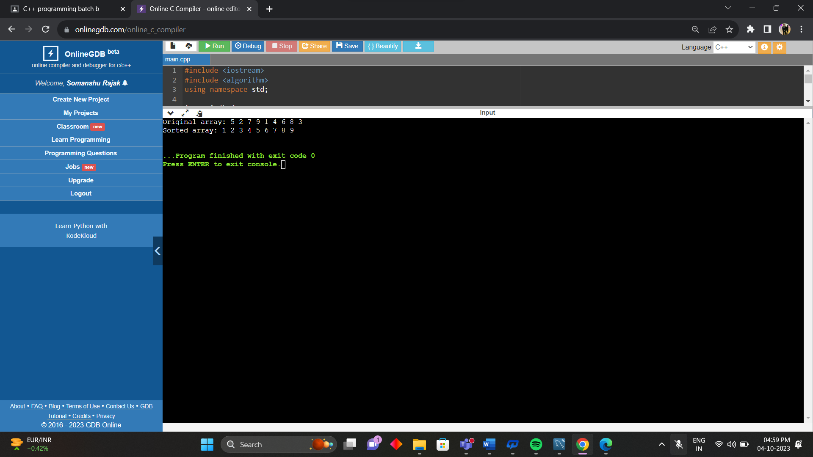

11. Write a program in C++ to calculate the square of the number using inline functions and macros both.

#include <iostream>

using namespace std;

#define SQUARE(x) ((x) \* (x))

inline int square(int x) {

return x \* x;

}

int main() {

int num;

cout << "Enter a number: ";

cin >> num;

cout << "Square of " << num << " using macro is: " << SQUARE(num) << "\n";

cout << "Square of " << num << " using inline function is: " << square(num) << "\n";

return 0;

}

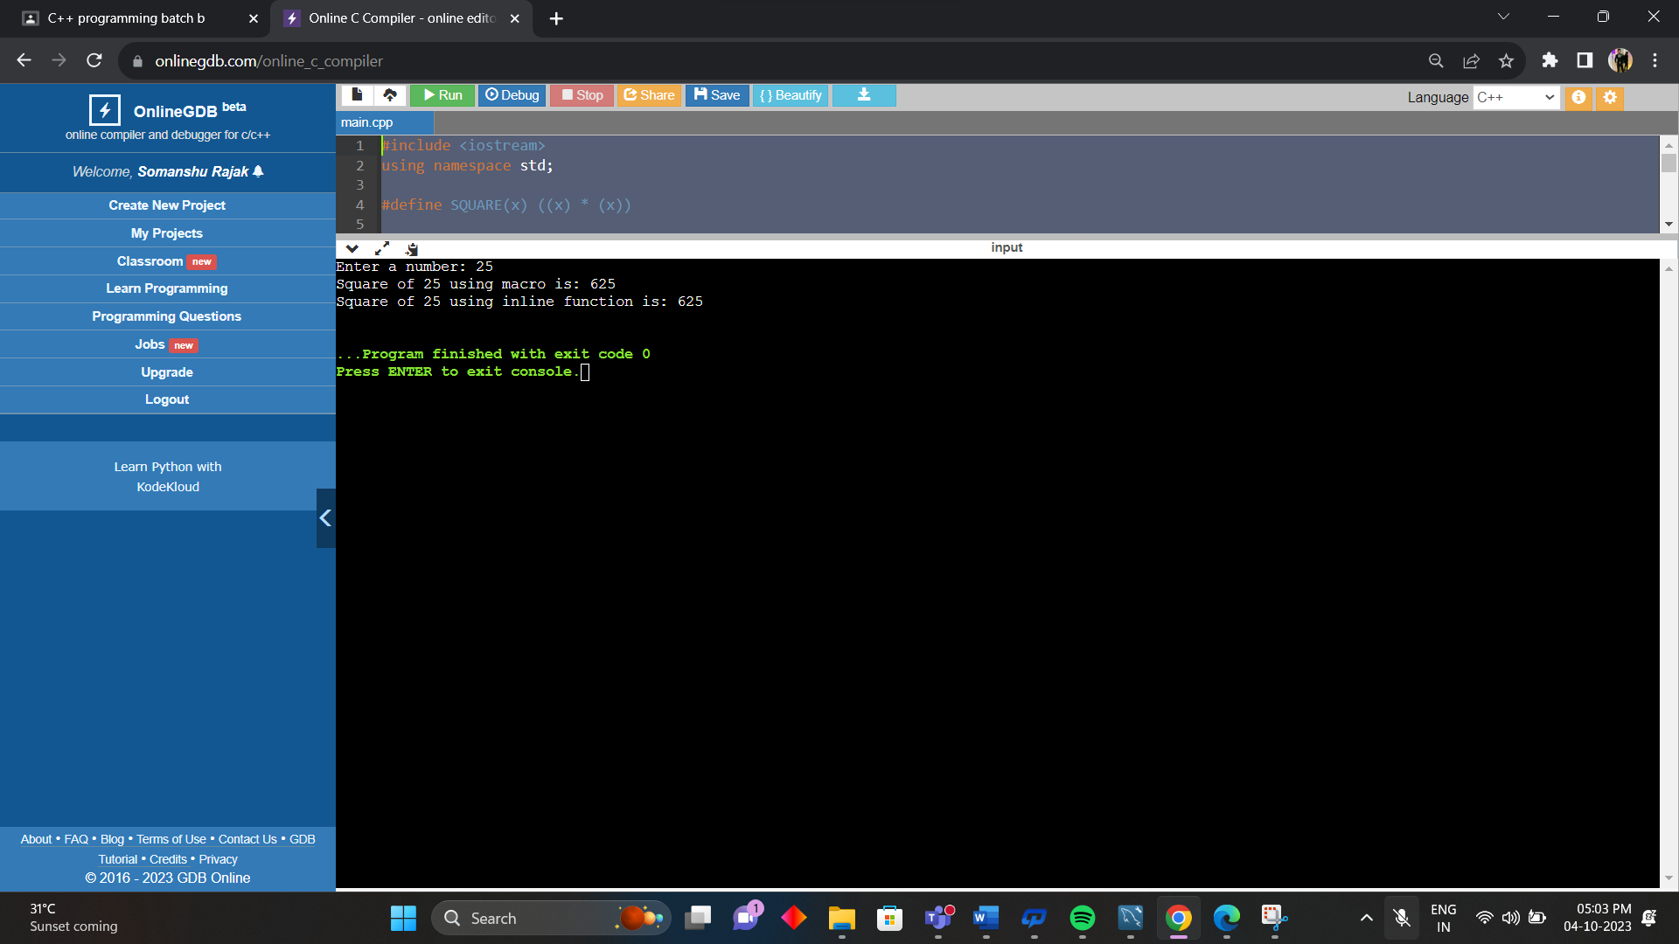

12. Write a program in C ++ to calculate area of all figures using the concept of function overloading.

#include <iostream>

#include <cmath>

using namespace std;

// Define a constant for pi

const double PI = 3.14159;

double area(double r) {

return PI \* r \* r;

}

double area(double l, double w) {

return l \* w;

}

double area(int b, int h) {

return 0.5 \* b \* h;

}

int main() {

double radius, length, width;

int base, height;

cout << "Enter the radius of a circle: ";

cin >> radius;

cout << "The area of the circle is: " << area(radius) << "\n";

cout << "Enter the length and width of a rectangle: ";

cin >> length >> width;

cout << "The area of the rectangle is: " << area(length, width) << "\n";

cout << "Enter the base and height of a triangle: ";

cin >> base >> height;

cout << "The area of the triangle is: " << area(base, height) << "\n";

return 0;

}

